Population Diversity Posttest (High School)

Science is easier to understand if you can make connections between what you know now and the new ideas you are studying. This is a test that will help us know what you know now.

Please answer these questions as carefully and completely as you can. If you aren’t sure of the answer, please write any thoughts that you have. If you can help us to understand how you think about these questions, then we can do a better job of explaining science in ways that make sense to you.

Please put your initials (not your full name) in these boxes:
Also put your initials on the top of each page.
First Middle Last
Date _______________________

Class ______________________ Teacher ____________________________

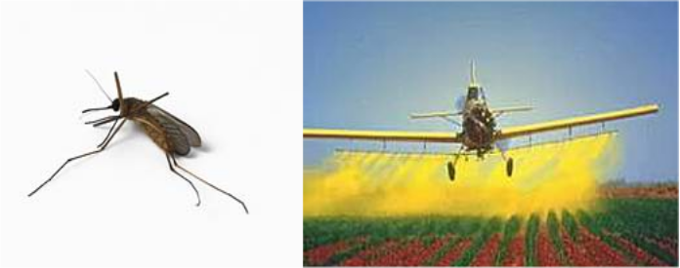

1. Farmers often use pesticides to help prevent insects from eating their crops. Over time, the insects slowly become resistant to these pesticides, and so the farmers have to use different pesticides to protect their crops. Tell a story about how the insects become resistant to the pesticides.

2. Put the following items in the boxes below, going from the smallest (on the left) to the largest (on the right). Be sure to include all the terms.

Population
Gene
Species
DNA
Ecosystem
Dog
Chromosome

Smallest Largest
atom |  |  |  |  |  |  |  | planet

3. Tell a “science story” connecting the four objects the in the image below.

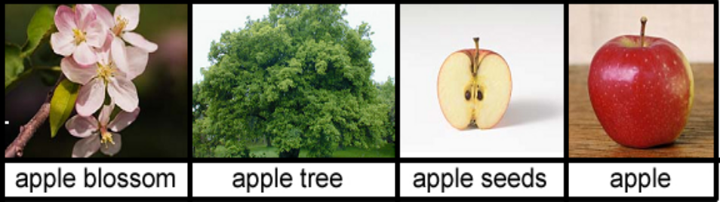

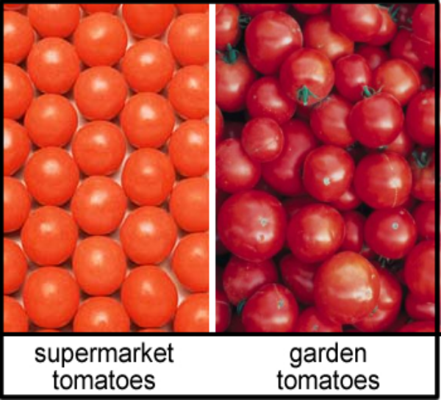
4. To the right are pictures of some tomatoes from the supermarket and some tomatoes grown in my garden. The supermarket tomatoes are all very similar, whereas the garden tomatoes are all different shapes and sizes. Below, give three reasons why the supermarket tomatoes are more alike than the garden tomatoes.
1.

2.

3.

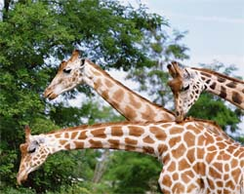
“During their lives, giraffes stretch their necks to reach leaves high in trees. This process gradually strengthens and lengthens their necks. Those giraffes that stretched the most have offspring with slightly longer necks.

5. Above is a description of how giraffes came to have long necks. Do you think that this a good explanation?
Circle one: | Yes | No
Explain why you chose your answer:

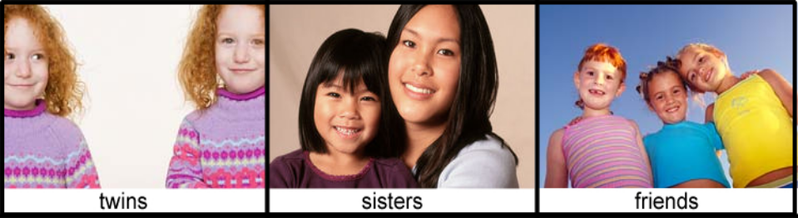

6. Above are pictures of twins, sisters and friends.

Why do the twins look more alike than the sisters?

Why do the sisters look more alike than the friends?

7. Imagine two groups of 30 elephants. Groups A contains elephants that are all slightly different, while Group B contains elephants that are all identical. Which of the two groups do you think is most likely to survive if there was a severe drought?

Circle one: | Group A | Group B | Both have an equal chance of surviving

Explain why you chose your answer:

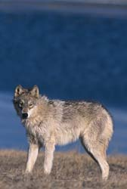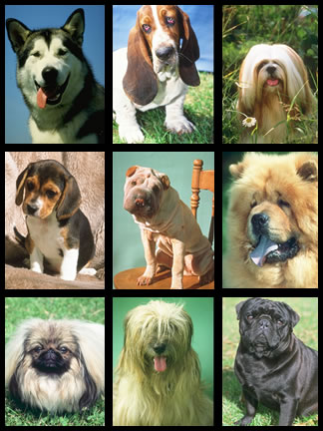

8. Evidence indicates that all modern dogs are descended from a wolf ancestor. In the box below, describe how all of the different breeds of dogs that we see today could have come from a single wolf ancestor.

9. When Europeans first came to Peru, the found that the Peruvians were growing a crop that they had never seen before: potatoes. Each Peruvian field contained many types of potatoes, as shown in the picture on the left. The Europeans selected the biggest and best type of potatoes (shown in the picture on the right), took that back to Europe, and planted fields containing just this one type of potato.

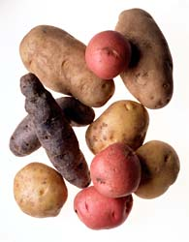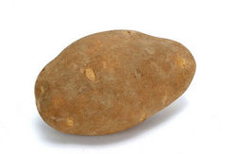
Peruvian fields European fields

What are the advantages and disadvantages of these two ways of growing potatoes?

 | Peruvian way | European way
Advantages
Disadvantages

10. Imagine a group of hundreds of tropical fish from a single species. Which statement below best describes the appearance of a group of fish such as this? Circle your answer below:
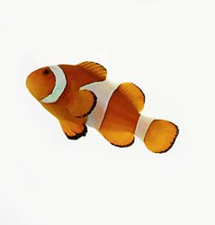
- The fish are all identical to each other.
- The fish are all identical on the inside, but have many differences in appearance.
- The fish are all identical in appearance, but are all different on the inside.
- The fish share many characteristics, but also vary in many features.
- The fish are all completely unique and share no features with other fish.
Explain why you chose your answer:

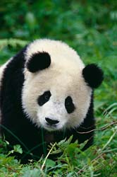
11. There are so few of some endangered species like the giant panda, that many of the remaining individuals live in zoos and wildlife sanctuaries, where scientists try to help endangered species in captive breeding programs. One of the goals of these breeding programs is to try to increase the genetic diversity in the remaining population of pandas.

Why do you think these breeding programs want to increase genetic diversity in the remaining population of pandas?

How could these breeding programs go about increasing genetic diversity in the remaining panda population?

